Di-TOOLS MANUAL
USER GUIDE 2
1. COPY DRAWING OBJECTS 2
2. MOVE FILE 3
3. CREATE DRAWING 4
4. EXPORT TO PDF [DWG] 5
5. EXPORT PDF SET 8
6. EXPORT PDF SERIES 10
7. EXPORT TO DXF 11
8. EXPORT TO STP 14
9. EXPORT TO BIM 15
10. COMPONENT SIZE 17
11. NAME BODIES 19
12. CUSTOM QUANTITY 20
13. SUM QTY 21
14. DRAWING STATUS 22
15. UPDATE PROPERTY 23
16. GET SURFACE AREA 24
17. STANDARD PROPERTIES 24
18. PLACE COMPONENTS 26
20. PATTERN QTY FROM EXCEL 27
21. SAVE AND REPLACE COMPOENTS 27
22. REVISION-SAVE AS-REPLACE 28
23. BOM STRUCTURE 29
24. SHEET METAL TO NORMAL 30
25. EXPORT STEP BY CATEGORY 31
26. EXPORT COMPONENTS TO EXCEL 32
27. SYNC NAME 34
28. MANAGE VIEWS 35
29. COPY DESIGN 36
30. CHECK MISSING FILES 38
31. DELETE NON-SOLID 39
32. DELETE HIDDEN COMPONETS 39
33. EXPORT CUSTOM PRODUCTION 40
34. MODEL PLANES 42
35. GET BODY NAME IN BALLOON 42
37. IPROPERTIES 44
INSTALLATION 47

USER GUIDE

COPY DRAWING OBJECTS
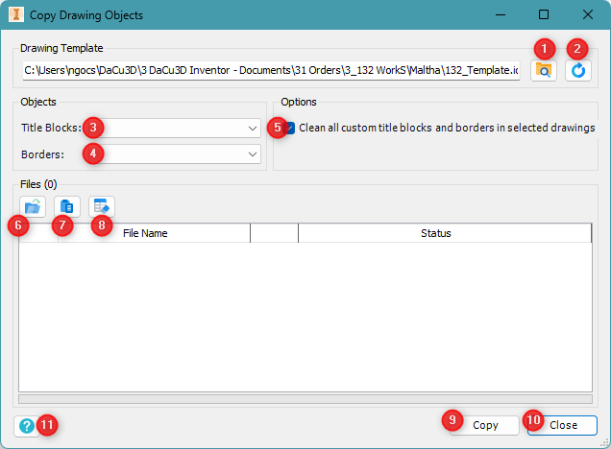
Overview
The Copy Drawing Objects tool allows users to copy title blocks and borders from a specified template to selected drawings. Additionally, it provides an option to clean custom title blocks and borders before copying new ones.
Interface
- Toolbar
- (1) Open Template: Click this button to browse and select a drawing template.
- (2) Load Template: Reload the current template.
- Object Selection
- (3) Title Blocks: Choose a title block from the dropdown list.
- (4) Borders: Choose a border from the dropdown list.
- Options
- (5) Clean all custom title blocks and borders in selected drawings: Enable this checkbox to remove existing custom title blocks and borders before applying the new ones.
- File Management
- (6) Add Files: Click to add drawing files to the list.
- (7) Past Files from Clipboard: Click to remove a selected file from the list.
- (8) Clear File List: Click to remove all files from the list.
- Actions
- (9) Copy: Start the process of copying the selected objects to the drawings.
- (10) Close: Exit the tool.
- (11) Help: Open this user guide.
Usage Steps
- Click Open Template (1) and select a drawing template.
- Choose the desired Title Block (3) and Border (4).
- (Optional) Enable Clean all custom title blocks and borders (5) if necessary.
- Add drawing files using Add Files (6).
- Click Copy (9) to apply the changes.
- Review the status of each file in the list.
- Click Close (10) to exit when done.
This tool streamlines the process of updating multiple drawings efficiently.
Additional Notes
- Ensure that all selected drawing files are accessible and not open in another application.
- If any errors occur during the process, check the "Status" column for details.

MOVE FILE
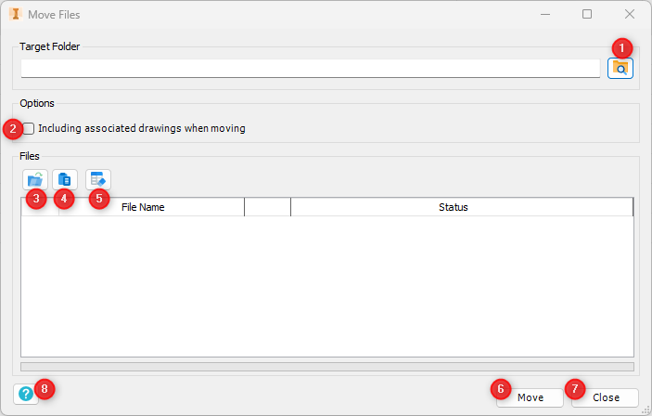
Overview
The Move Files tool allows users to move selected files to a specified target folder. Additionally, it provides an option to include associated drawings when moving files.
Interface
- Toolbar
- (1) Browse Target Folder: Click this button to select the destination folder.
- Options
- (2) Including associated drawings when moving: Enable this checkbox to move related drawing files along with the selected files.
- File Management
- (3) Add Files: Click to add files to the list.
- (4) Paste Files from Clipboard: Click to paste copied file paths into the list.
- (5) Clear File List: Click to remove all files from the list.
- Actions
- (6) Move: Start the process of moving the selected files.
- (7) Close: Exit the tool.
- (8) Help: Open this user guide.
Usage Steps
- Click the Browse Target Folder (1) and select the destination folder.
- (Optional) Enable Including associated drawings when moving (2) if necessary.
- Add files using Add Files (3).
- Click Move (6) to transfer the files.
- Review the status of each file in the list.
- Click Close (7) to exit when done.
Additional Notes
- Ensure that all selected files are accessible and not open in another application.
- If any errors occur during the process, check the "Status" column for details.

CREATE DRAWING
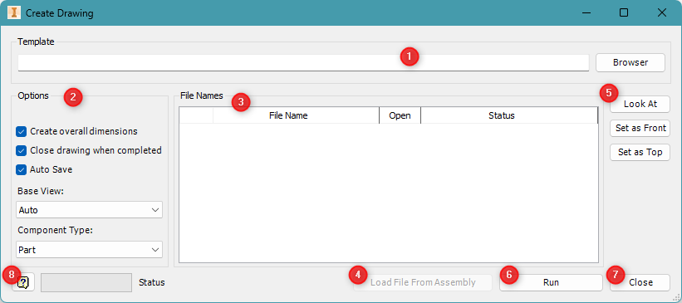
Overview
The Create Drawing tool allows users to generate 2D drawings from 3D Inventor models using a selected template. It includes options for automatic dimensions, view orientation, and file handling behavior.

Interface
- Template Selection
- (1) Template – Specify the path to the drawing template (.idw or .dwg) used to create the new drawings. Click Browser to select a file.
- Options
- (2) Options Panel – Configure default drawing behaviors:
  - Create overall dimensions – Adds bounding dimensions automatically.
  - Close drawing when completed – Auto-closes drawing files after creation.
  - Auto Save – Saves drawing files automatically after generation.
  - Base View – Choose the base view orientation (Auto, Front, Top, Right, etc.).
  - Component Type – Choose between Part or Assembly.
- File Names List
- (3) File Table – Displays the files being processed:
  - File Name – Name of the model to draw.
  - Open – Indicates whether the file is currently open.
  - Status – Shows results (e.g., Success, Error, In Progress).
- Assembly Loader
- (4) Load File From Assembly – Allows batch loading of files directly from an assembly to auto-create drawings for each component.
- Orientation Tools
- (5) Look At – View control buttons:
  - Set as Front – Assign current view as front.
  - Set as Top – Assign current view as top.
These are used to control base view orientation manually.
- Actions
- (6) Run – Start the drawing creation process.
- (7) Close – Exit the tool.
- Help
- (8) Help Icon – Access this guide or get quick tips about how to use the tool.

Usage Steps
- Select a drawing template (1).
- Adjust options like dimensions, base view, and auto-save (2).
- Past the File Names of Part or Assembly (CTRL) or if you are opening an assembly, you can use Load files or use Load File From Assembly (4) to populate the table.
- Use Look At tools (5) if you need to redefine front/top views.
- Click Run (6) to generate drawings.
- Click Close (7) when done.

Additional Notes
- Make sure your template includes desired title blocks and standards.
- When working with large assemblies, Auto Save and Close drawing help streamline batch generation.

EXPORT TO PDF [DWG]
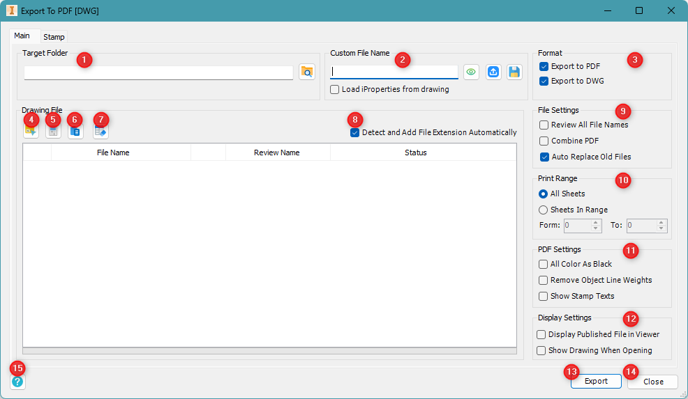
Overview
The Export to PDF tool allows users to export drawings to PDF or DWG format with customizable options, including sheet selection, file naming, stamping, and additional export settings.
Interface
- Toolbar
- (1) Browse Target Folder: Click this button to select the destination folder for the exported files.
- (2) Custom File Name: Update or define the custom file name format. You can load and save the format using the adjacent buttons.
- (3) Format: Select one or both output types:
• Export to PDF
• Export to DWG
- Drawing File Management
- (4) Add From Folder
Add multiple drawings from a selected folder.
- (5) Load By iProperties (Only works when an assembly is opened)
- (6) Paste From Clipboard
Paste file paths directly from clipboard into the list.
- (7) Clear
Remove all files from the current list.
- File Settings
- (8) Detect and Add File Extension Automatically
Automatically append the correct file extension (.pdf or .dwg) based on your export selection.
- (9) File Settings
  - Review All File Names
  - Combine PDF
  - Auto Replace Old Files
- (10) Print Range
  - All Sheets
  - Sheets In Range (manually define range using the input boxes)
- (11) PDF Settings
  - All Color As Black
  - Remove Object Line Weights
  - Show Stamp Texts
- (12) Display Settings
  - Display Published File in Viewer
  - Show Drawing When Opening
- Actions
- (13) Export: Start the export process for all listed files.
- (14) Close: Exit the tool.
- TEMP
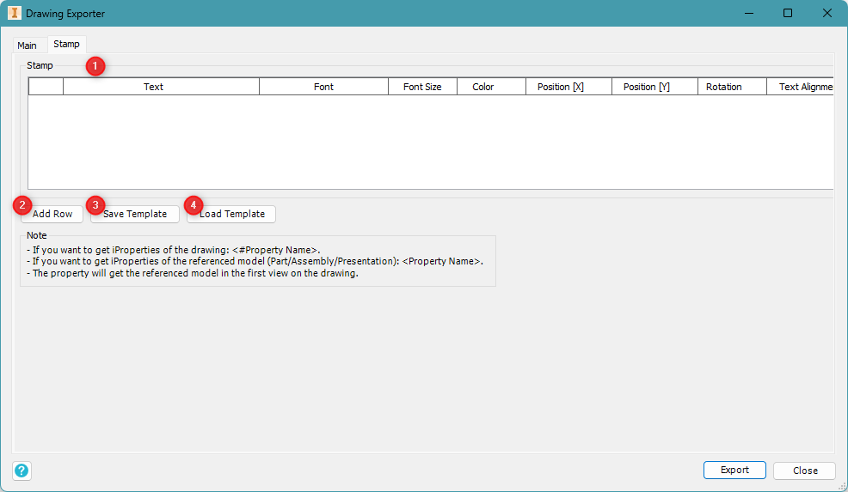
- (1) Stamp Table: Displays the list of stamp items to be applied. Each row allows you to configure the following properties:
  - Text: The content of the stamp (can include iProperties).
  - Font: The font type used for the text.
  - Font Size: The size of the text.
  - Color: The color of the text.
  - Position [X], [Y]: The coordinates on the drawing where the stamp will be placed.
  - Rotation: The angle of rotation for the text.
  - Text Alignment: Horizontal or vertical alignment of the text.
- (2) Add Row: Add a new row to the stamp table for defining a new text stamp.
- (3) Save Template: Save the current list of stamps and their configurations as a template.
- (4) Load Template: Load a previously saved stamp template to reuse common setups.

Usage Steps – Main Tab
- Click Browse Target Folder to select where the exported PDFs will be saved.
- (Optional) Enter a Custom File Name.
- Configure export options based on your requirements.
- Add drawing files using Select from Folder/ Load from iProperties/Paste from Clipboard.
- Click Export to start exporting the drawings to PDF.
- Review the status of each file in the list.
- Click Close to exit when done.
Additional Notes
- Ensure that all selected drawing files are accessible and not open in another application.
- If any errors occur during the process, check the "Status" column for details.

Usage Steps – Temp Tab
- Use Add Row to create a new stamp.
- Fill in the details for Text, Font, Size, Color, Position, and Rotation in the Stamp Table.
- Use the <#Property Name> format to pull iProperties from the drawing.
  - For drawing properties: <#Property Name>
  - For referenced model properties: <Property Name>
- Save the configuration using Save Template if needed.
- Reuse saved settings using Load Template`.
Additional Notes
- To reference drawing iProperties, use: <#Property Name>
- To reference model (Part/Assembly/Presentation) iProperties, use: <Property Name>
- The referenced model is taken from the first view on the drawing.

EXPORT PDF SET
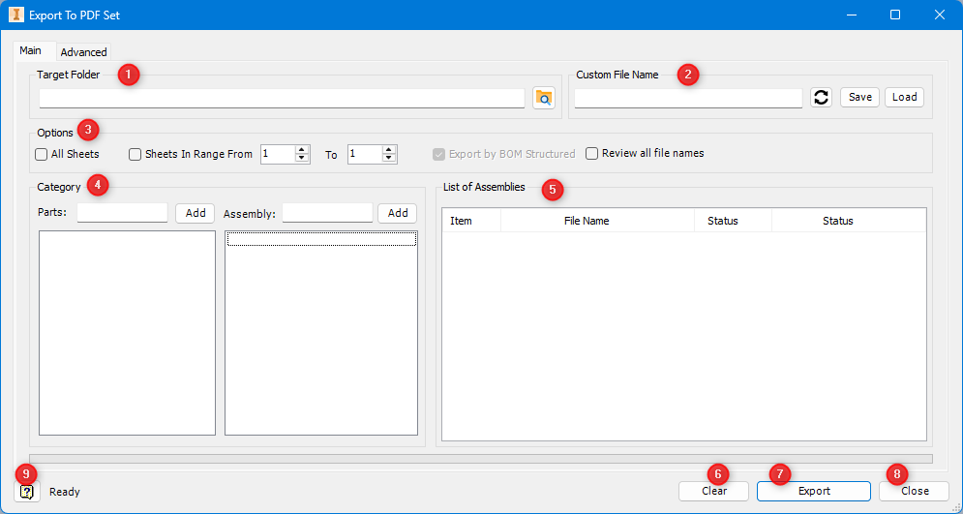
Overview
The Export to PDF Set tool automates batch exporting of Inventor drawings to PDF format based on part/assembly categories and customizable sheet range and naming rules. This is especially useful for organizing production sets by category.
Interface
- Target Folder
- Click the folder icon to select where exported PDF files will be saved.
- Custom File Name
- Define the file naming format. Use <PropertyName> tags or fixed text.
- Use the Save and Load buttons to manage file name templates.
- Options – Sheet Range
- All Sheets: Export all sheets from each drawing.
- Sheets in Range From–To: Export a selected range of sheets (e.g., only sheet 1 or 1–2).
- Optionally check Review all file names to confirm before exporting.
- Category – Parts & Assemblies
- Enter a keyword (e.g., C1, CIN, ASSY, etc.) and click Add to define which categories to include in the export.
- List of Assemblies
This table displays the drawing files matching the selected categories. It includes:
- Item: Row index
- File Name: Name of the drawing
- Status: Export status (Success, Error, etc.)
- Clear
- Clears all selected categories and file lists.
- Export
- Begins exporting drawings to PDF using the specified folder, naming format, sheet settings, and categories.
- Close
- Exits the tool.
- Help Icon
- Open this user guide or shows tooltips for quick reference.
- Advanced Tab Load by Property (This function is only work when open an assembly)
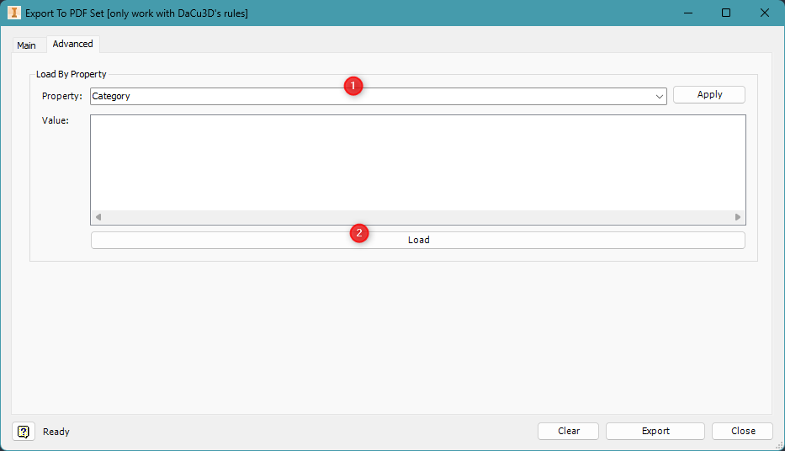
- Property Selection:
  - Choose the iProperty you want to filter by (e.g., Category, Keywords, …). Once selected, click Apply to display all available values for that property.
  - Value: After applying the property filter, this field displays all available values. You can select one or multiple values from the list.
- Load: After choosing the property and selecting the values, click Load to populate the drawing list on the Main tab with files that match the selected criteria.

Usage Steps
- Set the Target Folder (1) to store exported PDFs.
- Define the Custom File Name (2) or load an existing template.
- Choose to export All Sheets or a Sheet Range (3).
- Enter and add Part and Assembly categories (4) to filter files.
- Review the List of Assemblies (5) to be exported.
- Click Export (7) to start the batch export.
- Use Clear (6) to reset inputs or Close (8) when finished.

Additional Notes
- This tool is optimized for DaCu3D-style category structures.
- The naming template supports iProperty-driven automation.
- Exported PDFs follow consistent naming and folder structure for easy project documentation.

EXPORT PDF SERIES
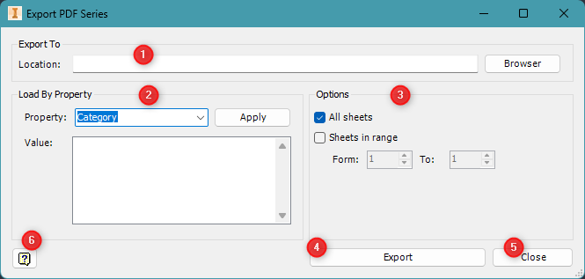
Overview
The Export PDF Series tool enables batch-exporting of drawings to PDF format based on custom iProperty filters. It supports full or partial sheet exports and organizes output using configurable paths.

Interface
- Export Location
- (1) Location – Set the folder where all exported PDFs will be saved. Use the Browser button to select the directory.
- Load By Property
- (2) Property Filter – Export files based on a selected iProperty:
  - Property – Choose a custom property such as Category, Project, or Material.
  - Value – Define one or more values (e.g., C1, Mech) to filter target drawings.
  - Apply – Load matching files based on the selected property and values.
- Options
- All sheets – Export all sheets in each drawing.
- Sheets in range – Export only a specific range (e.g., from Sheet 1 to 2).
  - Set the From and To fields to define the sheet range.
- Actions
- (4) Export – Begin the batch export process using current filters and settings.
- (5) Close – Exit the tool.
- Help
- (6) Help Icon – Opens this guide or in-app tips for assistance.

Usage Steps
- Select the export Location (1) where PDF files will be saved.
- Use the Property dropdown (2) to choose a filtering iProperty (e.g., Category).
- Enter one or more Values and click Apply.
- Choose whether to export All sheets or define a Sheet range (3).
- Click Export (4) to begin the process.
- Click Close (5) when finished.

Additional Notes
- Ideal for organized exports by category, project, or status.
- Each drawing is exported into the selected folder with naming retained.
- Ensure the property and value combinations are correctly set to match files.

EXPORT TO DXF

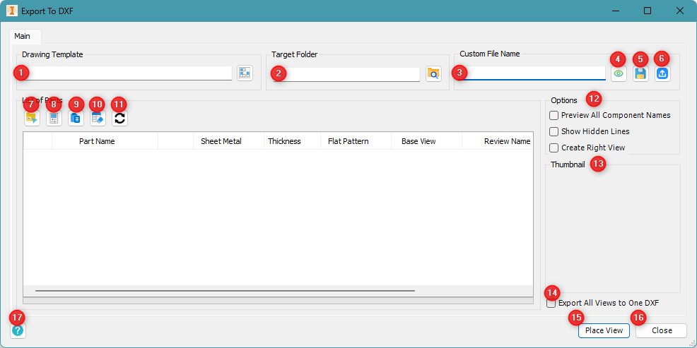
Overview
The Export to DXF tool allows users to export flat patterns or sheet metal parts from Inventor into DXF format. This version provides a streamlined interface for selecting files, defining file naming patterns, applying a drawing template, and configuring export behaviors.

Interface
- Toolbar
- (1) Drawing Template: Select a drawing template file to control the exported DXF layout.
- (2) Target Folder: Click the folder icon to choose where exported DXF files will be saved.
- (3) Custom File Nam: Define a file naming pattern for your exported DXF files.
- (4) Refresh File Name: Reload the custom name field using current data.
- (5) Save Settings: Save the current export configuration (template, folder, name format, etc.).
- (6) Load Settings: Load previously saved settings.

- File Management
- (7) Add from Folder: Load parts from a selected folder.
- (8) Load by iProperties: only works when assembly is opened.
- (9) Paste from Clipboard: Paste file paths copied from the clipboard.
- (10) Clear List: Remove all parts from the list.
- (11) Reload File List: Update the list view or refresh file status and properties.

- Options (12)
- Preview All Component Names: View all component names before exporting.
- Show Hidden Lines: Include hidden geometry in the DXF output.
- Create Right View: Add a right-side view in addition to the flat pattern view.

- Thumbnail (13)
- Displays a preview image of the selected part (if available).

- Export Settings
- (14) Export All Views to One DXF: Combine multiple views into a single DXF file.

- Actions
- (15) Place View (Export): Start place all flat views into a DXF drawing template before Export.
- (16) Close: Exit the Export to DXF tool.
- (17) Help: Opens this guide or in-app tips for assistance.

Usage Steps – Main Tab
- Click Drawing Template (1) to choose a layout file.
- Set the Target Folder (2) to specify the save location.
- Enter a Custom File Name (3) or preview it with (4).
- Use (5) to save your current configuration, or (6) to load a previous one.
- Add parts with (7), (8), or (9). Use (10) to clear the list if needed.
- Refresh the part list with (11).
- Configure options under (12) such as hidden lines and right views.
- (Optional) View part thumbnails in section (13).
- Enable (14) to export all views into one DXF file.
- Click Place View (15) to add views into drawing and then Export (15) to generate the DXF files.
- Click Close (16) when finished.

Additional Notes
- Drawing templates control layout, view styles in exported DXFs.
- Previewing component names is helpful for validation before export.
- Ensure selected parts support flat pattern export for DXF generation.
- Use hidden line options and view controls to match manufacturing needs.
- The tool supports batch operations for efficient multi-part processing.

EXPORT TO STP
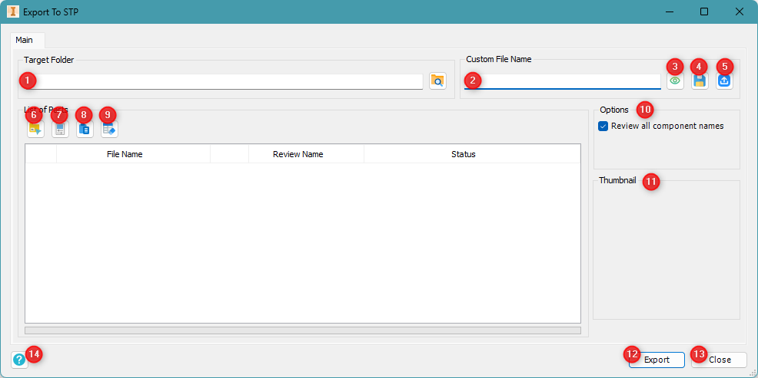
Overview
The Export to STP tool allows users to export component files to STEP format (.stp or .step) in batch mode. It includes options for customizing file names, managing file lists, previewing file status, and applying consistent export settings.

Interface
- 1. Toolbar
- (1) Target Folder: Choose where the exported STEP files will be saved.
- (2) Custom File Name: Enter a naming pattern to apply to the exported files.
- (3) Refresh File Name: Reload the custom name field using updated model data.
- (4) Save Settings: Save the current export configuration for reuse.
- (5) Load Settings: Load previously saved export settings.
- File Management
- (6) Add from Folder: Load parts from a selected folder.
- (7) Load by iProperties: only works when assembly is opened.
- (8) Paste from Clipboard: Paste file paths copied to your clipboard.
- (9) Clear List: Remove all files from the current list.
- Options
- (10) Review All Component Names: Show and review all component names before exporting.
- Thumbnail (11)
- Preview image of the selected part or assembly file (if available).
- Actions
- (12) Export: Start the STEP export process using the selected settings.
- (13) Close: Exit the Export to STP tool.
- (14) Help: Opens this guide or in-app tips for assistance.

Usage Steps
- Set the Target Folder (1) for saving your STEP files.
- Enter a Custom File Name (2).
- (Optional) Save your current setup using (4), or load a saved one with (5).
- Add files using (6), (7), or (8). Use (9) to clear the list.
- Enable the option Review All Component Names (10) if needed.
- (Optional) Preview files using the Thumbnail (11) area.
- Click Export (12) to start exporting to STEP.
- Click Close (13) when finished.
Additional Notes
- Only supported Inventor part or assembly files can be exported.
- File names will follow the pattern defined in the Custom File Name field.
- The status column will indicate success or error for each file.
- Use the settings buttons to ensure consistent exports across sessions.

EXPORT TO BIM
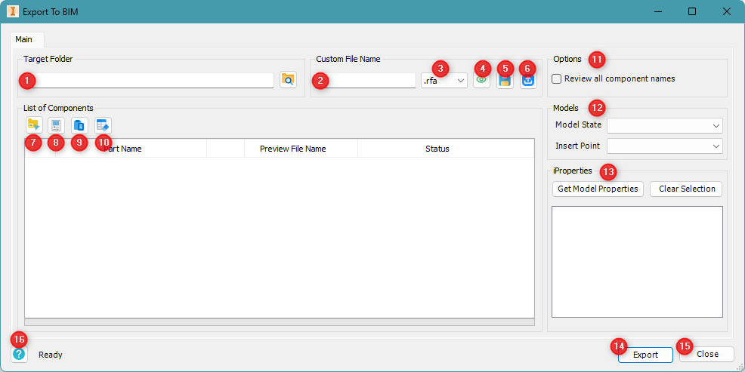
Overview
The Export to BIM tool allows users to export Inventor components to Revit Family format (.rfa). It includes options for file naming, model state selection, insertion point control, and property assignment, making it easier to prepare components for BIM workflows.

Interface
- Toolbar
- (1) Target Folder: Select the destination where Revit Family files will be saved.
- (2) Custom File Name: Define the export file name using fixed text or property placeholders.
- (3) File Extension: Select .rfa as the export format (default).
- (4) Refresh File Name: Reload the file name using the current component or property data.
- (5) Save Settings: Save the current export configuration for future reuse.
- (6) Load Settings: Load previously saved export settings.

- List of Components
- (7) Add from Folder: Load parts from a selected folder.
- (8) Load by iProperties: only works when assembly is opened.
- (9) Paste from Clipboard: Add file paths copied from clipboard into the list.
- (10) Clear List: Remove all components from the list.

- Options (11)
- Review All Component Names: Enable to review and confirm file names before export.

- Models (12)
- Model State: Select the desired model state to export for each component.
- Insert Point: Define the insertion point used in the exported Revit file.

- Properties (13)
- Get Model Properties: Extract and list available iProperties from the selected component.
- Clear Selection: Deselect all chosen properties.

- Actions
- (14) Export: Start the export process to generate .rfa files.
- (15) Close: Exit the Export to BIM tool.
- (16) Help: Opens this guide or in-app tips for assistance.

Usage Steps – Main Tab
- Set the Target Folder (1) for the exported .rfa files.
- Define a Custom File Name (2).
- Save or load export settings using (5) and (6).
- Add components using (7), (8), or (9). Use (10) to clear the list.
- (Optional) Enable Review All Component Names (11).
- Select a Model State and Insert Point (12).
- Click Get Model Properties (13) to retrieve and assign iProperties.
- Click Export (14) to start exporting the files.
- Press Close (15) when finished.

Additional Notes
- Only compatible Inventor components will be exported to Revit Family format.
- Custom file naming supports property-driven automation.
- Use model states and insert points to optimize Revit placement behavior.
- iProperties can be used to transfer metadata into the BIM environment.
- The status bar shows progress and any warnings or errors during export.

COMPONENT SIZE
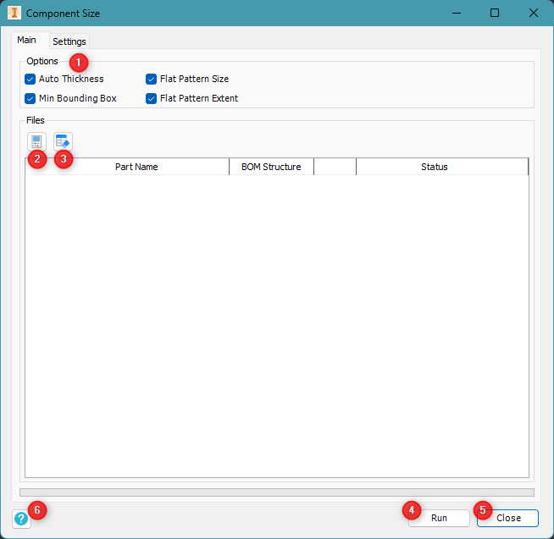
Overview
The Component Size tool analyzes and extracts size-related information from Inventor parts. It can calculate dimensions, assign property names, and output values based on different measurement settings.

Interface – Main Tab
- Options (1) - Enable or disable the following data extractions:
- Auto Thickness – Automatically detect the material thickness of each part.
- Min Bounding Box – Calculate the smallest bounding box that contains the geometry.
- Flat Pattern Size – Capture the size dimensions of the flat pattern.
- Flat Pattern Extent – Record the extents of the flat pattern view.

- 2. Files
- (2) Load by iProperties: only works when assembly is opened.
- (3) Clear – Remove all files from the list.

- 3. Actions
- (4) Run – Start processing all listed files using the selected options.
- (5) Close – Exit the Component Size tool.

- 4. Status Bar
- (6) Status – Displays the current tool status (e.g., “Ready”, “Processing”, or errors).

Usage Steps
- Select the options you want enabled under the Options (1) section.
- Add files to the list using Add File (2) or clear them with (3).
- Click Run (4) to begin extracting the size data.
- Monitor progress and results in the Status column.
- Click Close (5) to exit when finished.

Additional Notes
- Only part files are supported; assemblies will be ignored.
- Flat pattern options apply only to sheet metal parts with valid flat pattern definitions.
- Extracted results can be used for BOM, nesting, or documentation purposes.
Settings Tab
- Property Name Configuration: (1) Property Groups:
- Tool: Assign name for Auto Thickness property.
- Normal [Min Box]: Assign property names for standard thickness, width, and length.
- Flat Pattern [Min Box]: Assign property names for flat pattern thickness, width, and length.
- Flat Pattern Extents [Default]: Assign property names for width related to Y axis, length width related to X axis, and area.
- Measurement Settings
- (2) Linear Units: Select the unit (e.g., millimeter) and precision for linear values.
- (3) Area Units: Select the unit (e.g., square millimeter) and precision for area measurements.
- Actions
- (4) Default – Reset all fields to the default naming.
- (5) Save – Save current settings for future sessions.

NAME BODIES
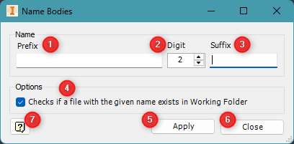
Overview
The Name Bodies tool allows users to generate standardized body names using a combination of prefixes, digits, and suffixes. It also checks for existing file names in the working folder to avoid duplication.

Interface
- Name Formatting
- (1) Prefix – Enter the text to appear at the beginning of each body name.
- (2) Digit – Set the number of digits for the numbering sequence (e.g., 2 → 01, 02, 03).
- (3) Suffix – Enter the text to appear at the end of each body name.
- Options
- (4) File Name Check – When enabled, the tool verifies if a body name already exists files in the working folder to prevent conflicts.
- Actions
- (5) Apply – Apply the naming convention to all selected bodies.
- (6) Close – Exit the Name Bodies dialog.
- Help
- (7) Help Icon – Open this user guide or view tooltip descriptions.

Usage Steps
- Enter a Prefix (1) and optionally a Suffix (3).
- Choose the desired Digit length (2) for automatic numbering.
- Check the Options (4) box to prevent overwriting existing names.
- Click Apply (5) to rename all selected bodies.
- Click Close (6) when finished.
Additional Notes
- The tool will generate names like PL-01-A, PL-02-A if Prefix = PL-, Digit = 2, Suffix = -A.
- If a name already exists and the option is checked, that body will be skipped or flagged.

CUSTOM QUANTITY
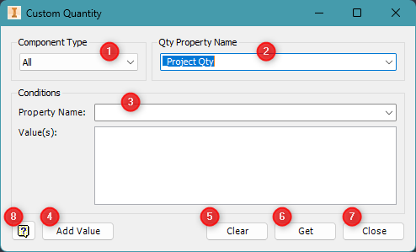
Overview
The Custom Quantity tool allows users to define a quantity property based on conditions applied to part properties. This enables dynamic BOM (Bill of Materials) management, tailored to project-specific rules.

Interface
- Quantity Settings
(1) Component Type – Choose the type of components the rule applies to (e.g., All, Parts only, Assemblies only).
(2) Qty Property Name – Enter the name of the custom quantity property to be calculated (e.g., Project Qty).

- Conditions Panel
(3) Property Name – Select the iProperty to filter components (e.g., Material, Category).
Value(s) – Enter one or more matching values that define the condition for inclusion in the quantity calculation.

- Actions
- (4) Add Value – Add a new value to the list of condition values.
- (5) Clear – Clear the list of added values.
- (6) Get – Apply the condition and compute the custom quantity values.
- (7) Close – Exit the Custom Quantity tool.
- (8) Help Icon – Open this user guide or show tooltips for more information.

Usage Steps
- Select the Component Type (1) to define the target scope.
- Enter a Qty Property Name (2) that will store the calculated quantity.
- In the Conditions section:
- Choose a Property Name (3).
- Enter one or more Value(s) and click Add Value (4).
- Click Get (6) to calculate and assign the custom quantity property.
- Click Clear (5) to reset the condition values if needed.
- Click Close (7) to exit.
Additional Notes
- The assigned quantity appears in the selected iProperty of each component.
- Use this tool to control part quantities in drawings, schedules, or Parts lists.
- Supports multi-condition evaluation for advanced filtering.

SUM QTY
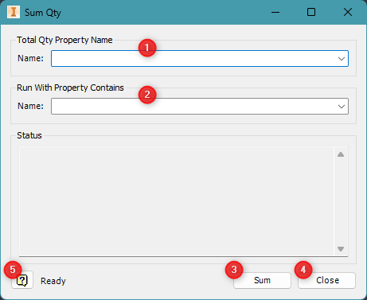
Overview
The Sum Qty tool totals quantities from components based on a specific property. It’s useful for accumulating custom quantity values (e.g., Project Qty) into a summary property in assemblies or parts.

Interface
- Property Selection
- (1) Total Qty Property Name – Select the property that will store the total summed value (e.g., Total Qty, Sum Project Qty).
(2) Run With Property Contains – Filter which components to include in the sum based on whether their properties contain a specific string. (e.g., <Qty1>+<Qty2>….).
- Actions
- (3) Sum – Run the calculation and assign the total quantity to the selected property.
- (4) Close – Exit the Sum Qty tool.
- (5) Help Icon – Open this user guide or display in-tool help messages.

Usage Steps
- Choose the Total Qty Property Name (1) where the summed result will be stored.
- Enter Run With Property Contains filter (2) to restrict which components are included in the calculation.
- Click Sum (3) to begin the calculation.
- View results or errors in the Status panel.
- Click Close (4) when finished.

Additional Notes
- This tool works well in combination with the Custom Quantity tool.
- The filter in (2) allows partial matching of property values for flexible control.
- Use this tool to summarize values into a parent component or main assembly property.

DRAWING STATUS
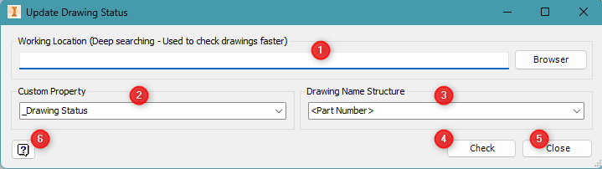
Overview
The Update Drawing Status tool checks the status of drawing files by comparing part properties with drawing filenames, helping to validate or synchronize drawing documentation across your project directory. It allows you to define the search path, select the custom property to check, and choose the naming structure to analyze.

Interface
- Working Location
- (1) Enter or browse to the folder where drawing files are stored.
- This location is deeply searched to speed up drawing checks.
- Custom Property
- (2) Select the iProperty (custom property) used to determine the drawing’s status (e.g., _Drawing Status).
- This property is compared between the part and the drawing.
- Drawing Name Structure
- (3) Choose how drawing filenames are structured, such as <Part Number> or another naming pattern.
- This helps the tool match part files to their corresponding drawings.
- Check
- (4) Run the comparison process.
- The tool will find the related drawing files and compare their status.
- Close
- (5) Exit the tool.
- Help
- (6) Click the Help icon to view this guide or get contextual help for each feature.

Usage Steps
- Specify the Working Location (1) by typing the path or clicking Browse.
- Select the relevant Custom Property (2) that stores the drawing status.
- Choose the appropriate Drawing Name Structure (3) to ensure correct matching.
- Click Check (4) to start the verification process.
- Review the results and take action if inconsistencies are found.
- Click Close (5) when done.

Additional Notes
- Ensure that part and drawing files follow consistent naming conventions for best results.
- This tool is especially useful for large projects where manual tracking is inefficient.
- Use the Help icon (6) for additional guidance or troubleshooting tips.

UPDATE PROPERTY
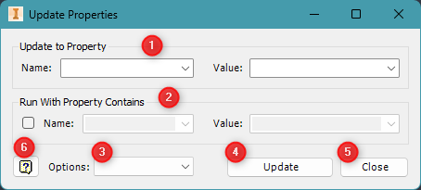
Overview
The Update Properties tool allows you to batch-update iProperties for multiple components. You can optionally filter the updates using specific property conditions and customize how the update behaves.

Interface
- Property Assignment
- (1) Update to Property
  - Name – Select the iProperty you want to update (e.g., Material, Project, Status).
  - Value – Enter or select the new value to assign to the selected property.
- Conditional Filter (Optional)
- (2) Run With Property Contains
  - Enable the checkbox to activate conditional filtering.
  - Name – Choose the property to be checked.
  - Value – Enter a value substring to filter matching components (e.g., only apply to parts with Category = Sheet Metal).
- Update Options
- (3) Options Dropdown – Choose behavior such as:
  - Update
  - Delete
- Actions
- (4) Update – Execute the property update based on your selections.
- (5) Close – Exit the tool.
- Help
- (6) Help Icon – Open this user guide or view inline help/tips for each option.
Usage Steps
- In the Update to Property section (1), select the property and value to apply.
- (Optional) Enable and configure Run With Property Contains (2) to limit updates to matching files.
- Choose additional behavior from the Options dropdown (3).
- Click Update (4) to apply changes.
- Click Close (5) to exit.
Additional Notes
- This tool helps ensure consistency across large assemblies or libraries.
- Filters are useful for avoiding accidental changes to unintended components.
- Use the Help icon (6) to understand each option more clearly before applying.

GET SURFACE AREA
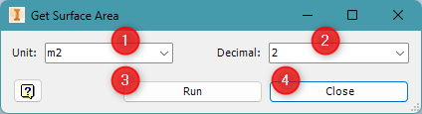
Overview
The Get Surface Area tool calculates the surface area of parts and presents the result in a selected unit and precision format. It helps you quickly extract surface values for material estimation or documentation.

Interface
- 1. Measurement Settings
- (1) Unit – Select the desired unit for the calculated surface area (e.g., m2, cm2, mm2).
- (2) Decimal – Choose the number of decimal places to display in the result (e.g., 0–5 digits).
- 2. Actions
- (3) Run – Calculate the surface area using the selected unit and decimal format.
- (4) Close – Exit the Get Surface Area tool.
- 3. Help
- (5) Help Icon – Opens this user guide or provides additional usage information.
Usage Steps
- Choose the Unit (1) to define the output measurement (e.g., square meters).
- Set the Decimal (2) precision for rounding results.
- Click Run (3) to compute and display the surface area.
- Click Close (4) to exit the tool.

Additional Notes
- This tool works best on solid bodies or surfaces with visible geometry.

STANDARD PROPERTIES
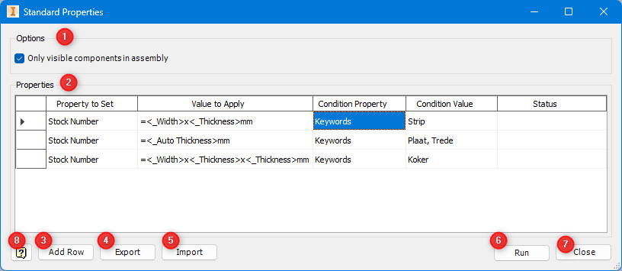
Overview
The Standard Properties tool allows users to batch-assign or update multiple iProperties for selected components. It supports conditional filtering, import/export of property sets, component type filtering, and a visibility filter to apply changes only to visible components.

Interface
- Options (1)
- Only visible components in assembly - When checked, the tool only applies updates to components currently visible in the active Inventor assembly.
- Properties Table (2)
- Property to Set - The iProperty to apply the value to (e.g., Stock Number).
- Value to Apply - The value to assign, which can include formulas like <_Width>x<_Thickness>.
- Condition Property - The property used for filtering (e.g., Keywords).
- Condition Value - Value(s) to match from the Condition Property to apply the update.
- Status - Displays the update result after pressing Run.
- Action Buttons
- Add Row (3) - Add a new iProperty rule to the list.
- Export (4) - Save the current property rules to a file.
- Import (5) - Load saved property rules from a file.
- Run (6) - Execute the update on all listed components.
- Close (7) - Exit the tool.
- Help
- Help Icon (8): Opens this user guide or in-app instructions.

Usage Steps
- Check Only visible components in assembly (1) if you want to limit updates to visible parts.
- Use Add Row (3) to define a property and its conditional update.
Enter:
- Property to Set (e.g., Stock Number)
- Value to Apply (e.g., =<_Width>x<_Thickness> or =<_Auto Thickness>)
- Condition Property (e.g., Keywords)
- Condition Value (e.g., Plaat, Trede)
- Repeat step 2–3 for additional rules.
- Click Run (6) to apply all updates.
- Use Export (4) to save configurations or Import (5) to reuse existing ones.
- Click Close (7) to exit.

Additional Notes
- Use formulas in Value to Apply for dynamic property generation.
- Multiple values in Condition Value can be separated by commas (,).
- Status will show success/failure for each component after running.
- This tool streamlines applying grouped property logic to categorized parts.

PLACE COMPONENTS
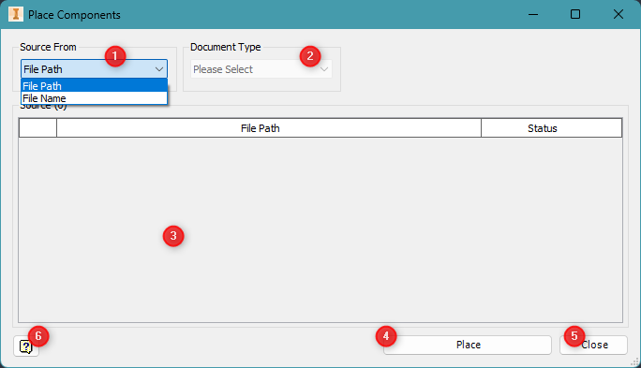
Overview
The Place Components tool allows users to place multiple parts or assemblies into an Inventor assembly based on either file paths or file names. This tool speeds up repetitive placement tasks in large assemblies.

Interface
- Source Selection
- (1) Source From – Choose the method used to locate files:
  - File Path – Use full file paths to find components.
  - File Name – Use just the file name (must exist in the project or search paths).
- (2) Document Type – Select the document type being placed (e.g., Part, Assembly).
- Component List
- (3) Source Table – Displays the list of components to be placed, along with their file paths and placement status.
- Actions
- (4) Place – Begin placing the listed components into the open Inventor assembly.
- (5) Close – Exit the Place Components tool.
- Help
- (6) Help Icon – Open this user guide or show in-tool instructions.

Usage Steps
- Select the Source From option (1): File Path or File Name.
- Choose the appropriate Document Type (2) based on the files being placed.
- Past File Names or File Paths into the Source Table (3).
- Click Place (4) to insert all listed components into the current assembly.
- Click Close (5) to exit the tool.

- Additional Notes
- When using File Name, make sure the files are discoverable in Inventor’s active project paths.
- The Status column helps confirm successful or failed placement of each item.
- This tool is ideal for automating the placement of common standard parts or subassemblies.

PATTERN QTY FROM EXCEL
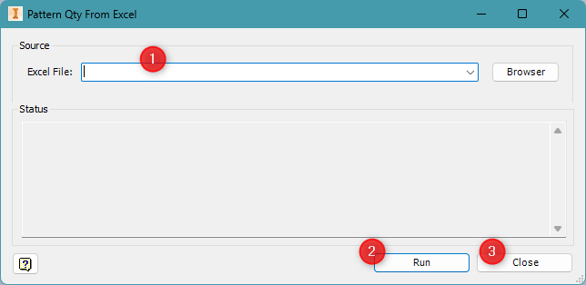
Overview
The Pattern Qty From Excel tool updates quantity patterns for components in an Inventor assembly based on values from an Excel file. It is useful for automating part patterning using pre-defined data.

Interface
- Source
- (1) Excel File – Select the Excel file that contains the quantity data. Use the dropdown or click Browse to locate and load the file.
- Actions
- (2) Run – Start reading the Excel file and apply pattern quantities to components.
- (3) Close – Exit the Pattern Qty From Excel tool.
- Help
- (4) Help Icon – Open this user guide or view additional in-tool help.

Usage Steps
- Select the Excel File (1) containing your pattern quantity data.
- Click Run (2) to apply quantities to the matching components in the open assembly.
- Check the Status panel for results and confirmation messages.
- Click Close (3) when done.

Additional Notes
- Make sure the Excel file includes matching identifiers (e.g., part numbers) and quantity values.
- The tool reads and applies data only if the format and values are compatible with the current assembly structure.
- Use the Status area to verify success and troubleshoot any mismatches.

SAVE AND REPLACE COMPOENTS
Overview
The Save and Replace Components tool allows users to create copies of selected components (parts or assemblies), rename them based on custom rules, and automatically replace the original components in the active Inventor assembly. This is useful for branching out new design variants from existing designs.
Usage Steps
- Select a component you want to duplicate.
- Launch the Save and Replace Components tool.
- Enter naming rules or mappings as needed (Prefix, Suffix, or Replace text).
- Choose a save location for the new files.
- Click Save to apply changes.
- Review the results in the assembly and save your work.

REVISION-SAVE AS-REPLACE
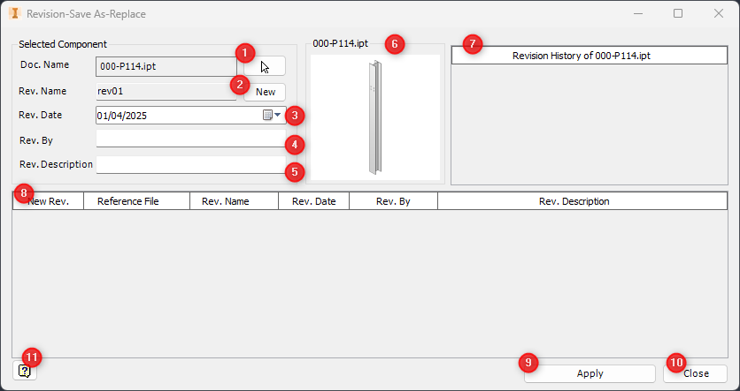
Overview
The Revision – Save As Replace tool allows users to create a new revision of an Inventor component. It saves the revised file under a new name, replaces the original component in the active assembly, and maintains a detailed revision history.

Interface
- Selected Component Panel
- (1) Doc. Name – Displays the name of the component selected for revision.
- (2) Rev. Name – Enter the name of the new revision (e.g., rev01). Click New to auto-generate the next revision name.
- (3) Rev. Date – Set the date of the revision using the calendar picker or by manual input.
- (4) Rev. By – Enter the initials or full name of the person creating the revision.
- (5) Rev. Description – Add a short explanation of the change, purpose, or scope of the revision.

- 2. Preview & History
- (6) Preview – Displays a thumbnail image of the selected component.
- (7) Revision History Label – Indicates the name of the component whose revision history is shown.
- (8) Revision History Table – Lists all parents that are containing the selected component, showing:
  - New Rev.
  - Reference File
  - Rev. Name
  - Rev. Date
  - Rev. By
  - Rev. Description

- 3. Actions
- (9) Apply – Save the new file as a revision, update the current assembly to use the new file, and log the revision into history.
(10) Close – Exit the tool without making any changes.

- 4. Help
- (11) Help Icon – Opens this user guide or provides in-tool assistance.

Usage Steps
- Select the component to revise; its Doc. Name (1) will display automatically.
- Enter the Rev. Name (2), or click New to auto-fill it.
- Set the Rev. Date (3), and fill in Rev. By (4) and Rev. Description (5).
- Verify the component preview (6) and review prior history (7, 8).
- Click Apply (9) to create and replace the revised component in the open assembly.
- Click Close (10) to exit the tool.

Additional Notes
- The tool duplicates the component file and replaces its reference in the current assembly.
- Helps maintain a clean and traceable revision history.
- Saved revisions appear in the table (8) and are useful for documentation and audits.
- Be sure to save the open assembly after applying the changes.

BOM STRUCTURE
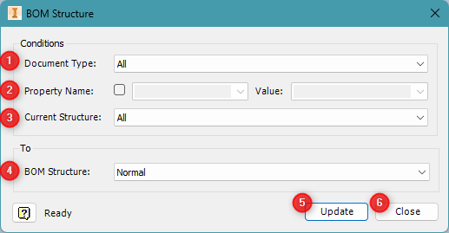
Overview
The BOM Structure tool allows users to batch-update the Bill of Materials (BOM) structure of Inventor components. This is useful for organizing assemblies into the correct BOM roles like Normal, Reference, Phantom, etc.

Interface
- Filter Conditions
- (1) Document Type – Choose which file types the update should apply to (e.g., All, Parts, Assemblies).
- (2) Property Name – (Optional) Activate the checkbox to apply changes only to components that contain a specific property. Then specify:
  - Property Name – The property to check.
  - Value – The value the property must contain for the update to be applied.
- (3) Current Structure – Filter components based on their current BOM structure (e.g., All, Normal, Reference, Phantom).
- Target BOM Structure
- (4) BOM Structure – Select the desired BOM structure to apply:
  - Normal
  - Reference
  - Phantom
  - Purchased
  - Inseparable
- Actions
- (5) Update – Apply the selected BOM structure to all filtered components.
- (6) Close – Exit the BOM Structure tool.

Usage Steps
- Choose a Document Type (1) to limit which files are affected.
- (Optional) Use Property Name and Value (2) to apply updates conditionally.
- Filter by Current Structure (3) to focus only on components with a specific BOM role.
- Choose the new BOM Structure (4) to assign.
- Click Update (5) to apply the changes.
- Click Close (6) when finished.

Additional Notes
- Only components matching all filter conditions will be updated.
- Useful when switching a group of parts to Reference or Phantom in one go.
- Always verify your changes in the assembly’s BOM view after applying updates.

SHEET METAL TO NORMAL
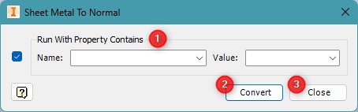
Overview
The Sheet Metal to Normal tool converts selected sheet metal parts in an Inventor assembly to standard (non-sheet metal) parts. This is helpful when components no longer require sheet metal features but should retain their geometry.

Interface
- Conditional Filter
- (1) Run With Property Contains – Enable this checkbox to restrict the conversion only to parts that match a specific iProperty:
  - Name – Select the iProperty to search in (e.g., Category, Material).
  - Value – Enter the keyword or string to match.
- Actions
- (2) Convert – Perform the conversion on all matching sheet metal components.
- (3) Close – Exit the tool.
- Help
- (4) Help Icon – Open this guide or access additional tooltips for guidance.

Usage Steps
- (Optional) Enable Run With Property Contains (1) to limit which parts are affected.
- Select the Property Name and enter a Value to filter parts.
- Click Convert (2) to change matching sheet metal parts to standard parts.
- Click Close (3) when done.

Additional Notes
- This operation does not remove geometry but switches the part type from sheet metal to normal.
- Useful in cases where flat pattern functionality is no longer needed.
- Filtering allows selective conversion to avoid unintended changes.

EXPORT STEP BY CATEGORY
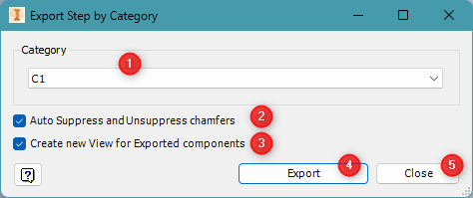
Overview
The Export STEP by Category tool allows you to export Inventor components to .STEP format based on a specific category. It includes options for automatic chamfer suppression and custom view creation for exported parts.

Interface
- Export Criteria
- (1) Category – Select the category of components to export. Only components that match this category will be processed.
- Export Options
- (2) Auto Suppress and Unsuppressed Chamfers – Enable this to automatically suppress chamfers before export and re-enable them afterward. This is useful when STEP output must exclude chamfered edges.
- (3) Create New View for Exported Components – If checked, a new named view is created for each exported part, ensuring consistent orientation during export.
- Actions
- (4) Export – Begin exporting all components that match the selected category and apply the selected options.
- (5) Close – Exit the Export STEP by Category tool.
- Help
- Help Icon – Click the question mark in the bottom-left to open this user guide or view in-app tips.

Usage Steps
- Choose the target Category (1) from the dropdown list.
- Enable or disable the Chamfer Suppression (2) and View Creation (3) options as needed.
- Click Export (4) to begin the export process.
- When finished, click Close (5) to exit the tool.

Additional Notes
- Make sure the parts have the correct Category iProperty set before running the tool.
- Exported .STEP files are saved in the default or user-specified export folder.
- Suppressed chamfers will be restored automatically if that option is selected.

EXPORT COMPONENTS TO EXCEL
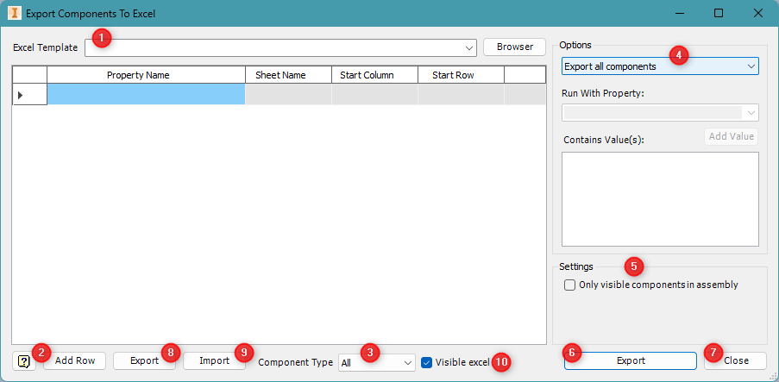
Overview
The Export Components to Excel tool allows users to export selected iProperties from an Inventor assembly into a structured Excel file using a predefined template. It supports conditional filtering, component type control, and multiple formatting options.

Interface
- 1. Template Selection
- (1) Excel Template – Select or browse for the Excel template that defines where and how the properties will be placed in the spreadsheet.
- 2. Property Mapping Table
- Property Name – The iProperty to export (e.g., Part Number, Category, Keywords Material).
- Sheet Name – The worksheet name in the Excel file to write to.
- Start Column – The Excel column where data writing will begin.
- Start Row – The Excel row where data writing will begin.
- 3. Component Filtering
- (2) Add Row – Add a new row to define another property to export.
- (3) Component Type – Select which type of components to include (e.g., All, Parts, Assemblies).
- 4. Export Options Panel
- (4) Export Mode – Choose how the components and their properties will be exported:
  - Export all components – Export the selected properties for all components.
  - Export components contain property – Export only components that have the specified property (use the field below to define the property name and values).
  - Export each property's value to each sheet – Export each selected property to its own individual Excel sheet.
- Run With Property (applies to the second mode above)
  - Property Name – Select the iProperty to filter by.
  - Contains Value(s) – Enter one or more values to match.
  - Add Value – Add values to the list.
- 5. Actions
- (6) Export – Start the export process based on selected filters and mappings.
- (7) Close – Exit the Export Components to Excel tool.
- (8) Export (Bottom Left) - Saved property-to-template mappings for the future use.
- (9) Import – Load saved property-to-template mappings.
- (10) Visible Excel – Automatically open the exported Excel file when finished.
- 6. Help
- Help Icon – Access this guide or additional in-tool help tips.

Usage Steps
- Load or browse for an Excel Template (1).
- Click Add Row (2) to define the properties you want to export.
- Choose a Component Type (3) and apply filters or values if needed.
- Select an Export Mode (4) and optionally enable Only visible components (5).
- Check Visible Excel (10) if you want the file to open after export.
- Click Export (6) to generate the spreadsheet.
- Use Close (7) to exit when done.

Additional Notes
- Make sure your Excel template file has the proper sheet and cell structure defined.
- Exported data is ideal for reports, BOMs, procurement lists, or documentation workflows.
- You can reuse property mappings with the Import (9) feature.

SYNC NAME
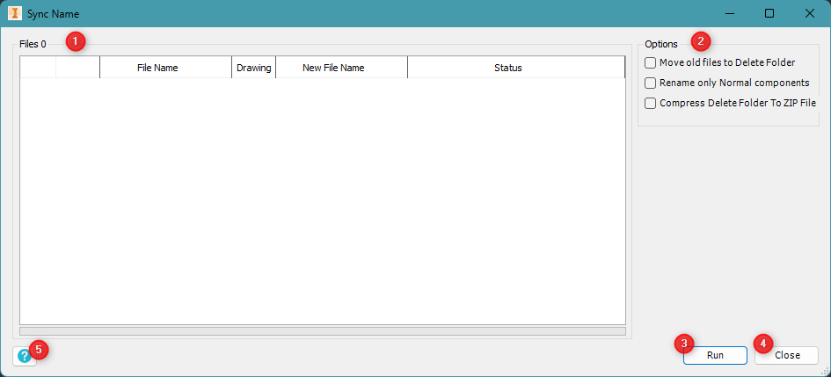
Overview
The Sync Name tool automatically renames components in your Inventor assembly to match a specific naming rule or reference. It includes options to move outdated files and filter by component type, helping to maintain clean and standardized file structures.

- Interface
- File List (1)
- Displays all loaded files along with:
- File Name – Current file name
- Drawing – Indicates if a drawing file is linked
- New File Name – Proposed new name
- Status – Status or result after processing
- Options (2)
- Move old files to Delete Folder – Moves renamed originals to a folder for archiving.
- Rename only Normal components – Skips components with BOM structures like Reference or Phantom.
- Compress Delete Folder to ZIP File – Compresses the archive folder into a ZIP after sync.
- Run (3)
- Executes the renaming process based on the selected options.
- Close (4)
- Exits the Sync Name tool.
- Help (5)
- Opens this user guide or shows tooltips for additional explanation.

Usage Steps
- Review the loaded file list shown in section (1).
- Enable Move old files to Delete Folder, Rename only Normal components, and/or Compress Delete Folder to ZIP File under Options (2) as needed.
- Click Run (3) to begin syncing file names.
- Check the Status column for results.
- Click Close (4) when complete.

Additional Notes
- The tool ensures naming consistency across project files.
- Moving and compressing old files can help with revision tracking and file cleanup.
- Make sure no files are open or locked during the sync process.

MANAGE VIEWS
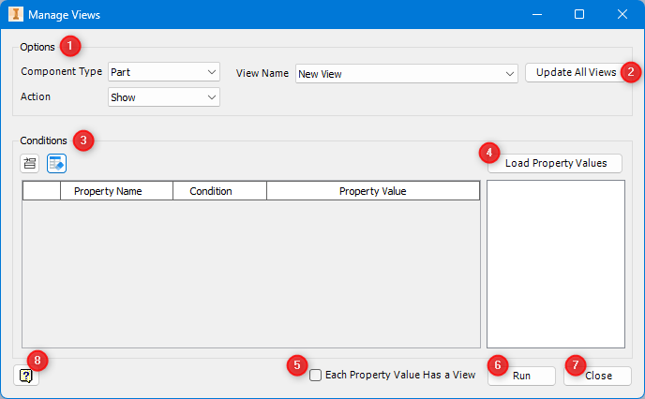
Overview
The Manage Views tool allows users to automatically create or update Inventor Design View Representations based on component properties. It controls visibility (Show/Hide) of parts or assemblies in specific views, streamlining drawing setup and visual configuration.
Interface
- Options Panel
- Component Type: Choose between Part or Assembly to filter which components are affected.
- Action: Select Show or Hide to define visibility behavior.
- View Name: Enter or select the name of the view representation to apply changes to.
- Update All Views
Enable this option to apply the visibility logic to all views in the project rather than just the selected view.
- Conditions Table
Add conditional rules using the toolbar above the table. Each rule includes:
- Property Name
- Condition (e.g., Equals, Contains)
- Property Value
- Load Property Values
Automatically populates available property names and values from the current document for easier rule creation.
- Each Property Value Has a View
When enabled, the tool will create one view per unique value of the selected property, and apply visibility settings accordingly.
- Run
Applies the action (Show/Hide) to all components that match the specified conditions in the selected (or all) views.
- Close
Exits the Manage Views tool.
- Help Icon
Opens this user guide or shows quick help tips in the UI.

Usage Steps
- Choose Component Type, Action, and View Name (1).
- Optionally enable Update All Views (2) to apply changes globally.
- Use the Conditions Table (3) to define filtering rules:
- Add conditions based on iProperties like Material, Category, etc.
- Use Load Property Values (4) to auto-fill available properties and values.
- Enable Each Property Value Has a View (5) if you want to generate a separate view per value.
- Click Run (6) to apply the changes.
- Click Close (7) to exit.

Additional Notes
- Works best when used before documentation to organize component visibility.
- View names will be auto created if they don’t exist yet.
- You can hide bolts, steel profiles, or specific materials based on flexible filters.

COPY DESIGN
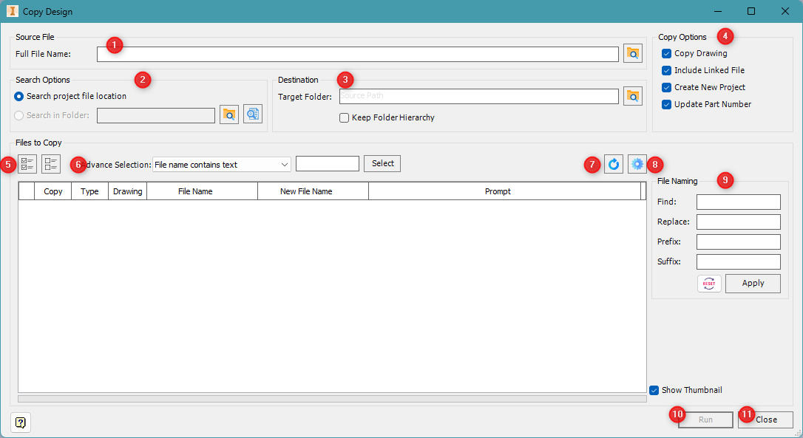
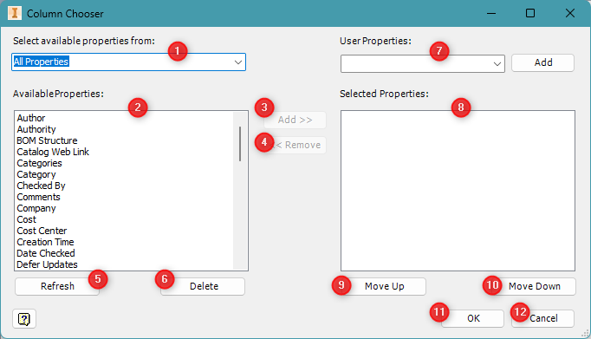
Overview
The Copy Design tool allows you to duplicate an Inventor design (including all references and drawings), rename files, update part numbers, and organize files into new folders or project structures. It is ideal for reusing and branching off from existing projects.

Interface
- Source and Destination
- (1) Full File Name – Select the main file (e.g., an assembly or part) you want to duplicate.
- (2) Search Options – Choose whether to search in the active project or specify a custom folder.
- (3) Target Folder – Set the destination for the new copies. Enable Keep Folder Hierarchy to preserve the original subfolder structure.
- Copy Options
- (4) Copy Options – Configure how the tool handles linked files:
  - Copy Drawing – Also copy associated .idw or .dwg files.
  - Include Linked File – Include all reference files.
  - Create New Project – Create a new .ipj project file in the destination.
  - Update Part Number – Update part numbers automatically during the copy process.
- Files to Copy
- (5) Files Table – Shows all components and references that will be duplicated. Columns include type, drawing status, old file name, and editable new name.
- (6) Advance Selection – Use filters to quickly select/deselect files (e.g., by file name, extension, etc.).
- Controls & Tools
- (7) File Controls – Access tools to expand/collapse file lists and configure view options.
- (8) Gear Icon (Settings) – allowing you to customize which properties are shown in the file list. This helps you track additional iProperties or metadata when copying and renaming files.
- File Naming
- (9) File Naming Options – Apply global renaming rules:
  - Find/Replace – Replace specific text in file names.
  - Prefix/Suffix – Add a prefix or suffix to new names. Click Apply to execute the changes or Reset to undo them.
- Actions
- (10) Run – Start the copy and rename process.
- (11) Close – Exit the tool.
- Help
- Help Icon – Access this user guide or in-app help for tooltips.
Usage Steps
- Select the Full File Name (1) of the top-level file to copy.
- Set your Search Options (2) and Target Folder (3).
- Configure the desired Copy Options (4).
- Use filters (6) and view controls (7) to manage the file list (5).
- Apply bulk renaming with File Naming (9), if needed.
- Click Run (10) to begin copying the design files.
- Click Close (11) to exit the tool when finished.

Additional Notes
- Ideal for project branching, product variants, and design templates.
- Review all file names in the table before running to prevent conflicts.
- “Show Thumbnail” helps visually confirm components.

CHECK MISSING FILES
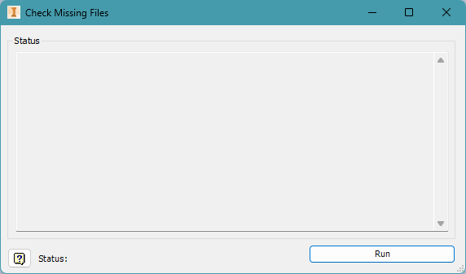
Overview
The Check Missing Files tool scans your current Inventor project or open design to detect missing reference files. It helps ensure file integrity before running operations like export, copy design, or revision control.

Interface
- Status Panel
- Status – Displays a detailed list of missing files, including paths or filenames that cannot be found. This helps you quickly locate which components need attention.
- Actions
- Run – Starts the scan for missing references.
- Status Bar (Bottom Left) – Shows the scan progress or summary result after execution.
- Help
- Help Icon – Opens this user guide or provides tooltips for quick in-app support.
Usage Steps
- Open the Inventor assembly or part file that you want to validate.
- Launch the Check Missing Files tool.
- Click Run to begin scanning for missing referenced files.
- Review the Status panel for any missing file entries.
- Locate and relink the missing files inside Inventor or your file system as needed.

Additional Notes
- This tool is helpful before performing Batch Exports, Copy Design, or generating BOMs, ensuring all linked files are intact.
- Missing files may include referenced parts, subassemblies, or drawing resources.
- Use the information in the status window to manually relink files using Inventor’s Resolve References tool if necessary.

DELETE NON-SOLID
Overview
The Delete Non-Solid tool is a quick utility that automatically removes any components in an assembly or part that are non-solid (e.g., empty, corrupt, or surface-only bodies). It helps clean up your design environment before finalizing exports or analysis.

Usage Steps
- Open the desired Inventor assembly.
- Run the Delete Non-Solid command.
- The tool will automatically:
  - Identify non-solid components.
  - Delete them from the model.

Additional Notes
- This tool does not affect visible solids or valid components.
- Non-solids include:
  - Bodies without volume
  - Surfaces without thickness
  - Corrupt imports with no geometry

DELETE HIDDEN COMPONETS
Overview
The Delete Hidden Components tool quickly removes components from an Inventor assembly that are currently invisible (hidden). It is designed to streamline assemblies by eliminating unused or temporarily hidden elements that are no longer needed.
Usage Steps
- Open the Inventor assembly you want to clean.
- Run the Delete Hidden Components tool.
- The tool will automatically:
  - Identify all components with visibility off.
  - Delete them from the model.

Additional Notes
- Components must be hidden using visibility toggles, not suppressed.
- Make sure important hidden parts (used for alternate views, configurations, etc.) are made visible before running this tool.

EXPORT CUSTOM PRODUCTION
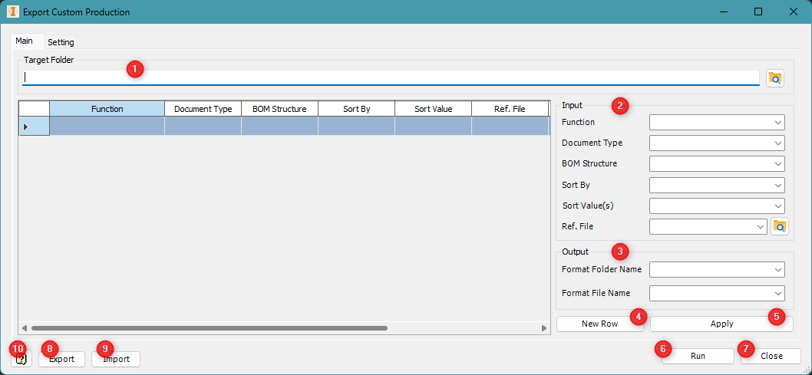
Overview
The Export Custom Production tool allows users to export Inventor components to various formats (PDF, DXF, STEP) based on custom logic such as document type, BOM structure, sorting rules, and naming patterns. This is useful for automating large-scale production exports with detailed control.

Main Tab – Interface Breakdown
- Target Folder Selection
- (1) Target Folder – Set the destination path where exported files will be saved.
- Rule Configuration Panel
- (2) Input Settings – Define how the export is applied using:
  - Function – Export function type (e.g., export, skip, preview).
  - Document Type – Specify Part, Assembly, etc.
  - BOM Structure – Filter by Normal, Reference, Purchased, etc.
  - Sort By / Sort Values – Control ordering of exports (optional).
  - Ref. File – Select a reference file to assist export logic.
- (3) New Row – Adds a new rule configuration line.
- (4) Apply – Apply the settings from the panel to the selected rule row.
- File Table
- Displays the rule rows with columns for:
  - Function
  - Document Type
  - BOM Structure
  - Sort parameters
  - Folder/File name formats
  - This allows detailed batch processing of export tasks.
- Actions
- (5) Run – Start the export process using all defined rules.
- (6) Close – Exit the tool.
- Import/Export Rules
- (7) Import – Load a saved export configuration.
- (8) Export – Save the current export rules to a file for reuse.
- Help
- (9) Help Icon – Opens this user guide or tooltips for in-tool support.
Setting Tab – Export Options
- PDF Options
- (1) PDF Export Options
  - All sheets
  - All color as black
  - Remove object line weights
  - Display published file in viewer
  - Sheets in range: Select a range using Form – To values
- STEP Options
- (2) Auto Suppress and Unsuppressed Chamfers – Useful for cleaner STEP output where chamfers should not appear.
- Template Selection
- (3) File Templates – Assign custom templates for:
  - DXF (Show Label)
  - DXF (Hide Label)
  - STEP Template
Browse and select .idw, .dxf, or .step templates that control export formatting or labeling behavior.

Usage Steps
- Choose your Target Folder (1).
- Create a rule row using New Row (3), fill in rule details (2), and click Apply (4).
- Repeat for each rule needed.
- Switch to the Setting tab and configure PDF/STEP options and templates.
- Click Run (5) to export all components.
- Use Export (8) and Import (7) to manage rule sets for future runs.

Additional Notes
- Each rule operates independently and can be tailored to specific document types or BOM structures.
- Templates allow strict control over output layout for manufacturing or client delivery.
- Combine with revision or folder naming formats for full automation.

MODEL PLANES
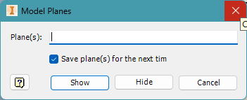
Overview
The Model Planes tool allows users to quickly show or hide specific work planes in a 3D model (part or assembly) by entering their names. It is useful for toggling visibility during modeling, review, or documentation tasks.

Interface
- Input
- Plane(s) – Type the name(s) of the plane(s) you want to control visibility for (e.g., XY Plane, Right, Work Plane1). You can enter multiple names separated by commas or spaces.
- Option
- Save plane(s) for the next time – When checked, the tool remembers the entered plane names for your next session, saving time for repetitive tasks.
- Actions
- Show – Makes the specified planes visible in the model.
- Hide – Hides the specified planes.
- Cancel – Closes the tool without making changes.
- Help
- Help Icon – Opens this user guide or in-tool tips.
Usage Steps
- Type one or more Plane names in the input field.
- Check or uncheck Save plane(s) for the next time as needed.
- Click Show to make the planes visible or Hide to make them invisible.
- Use Cancel to exit without applying changes.

Additional Notes
- This tool is ideal for managing construction geometry in large or complex models.
- Ensure that plane names are correctly typed; spelling must match exactly as listed in the browser.
- Frequently used with derived parts, multi-body modeling, or assembly constraints.

GET BODY NAME IN BALLOON
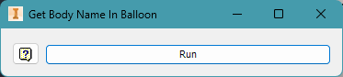
Overview
The Get Body Name in Balloon tool allows users to automatically update drawing balloons to display the Body Name instead of the default item number or part number. It is particularly useful for multi-body part drawings where individual bodies must be labeled clearly.

Interface
- Actions
- Run – Executes the command.
- Help
- Help Icon – Opens this user guide or tooltip for brief assistance.
Usage Steps
- Select the balloon that you want to get the name.
- Click Run.
- Balloons referencing body-level items will be updated to show their respective Body Name.
- Check the drawing to confirm correct labeling.

- Additional Notes
- Works best when using multi-body part modeling workflows.
- Ensure that each solid body has a Body Name property assigned in the 3D model.

IPROPERTIES
This lightweight version allows you to view and edit basic file information and perform actions quickly without accessing the full property set.
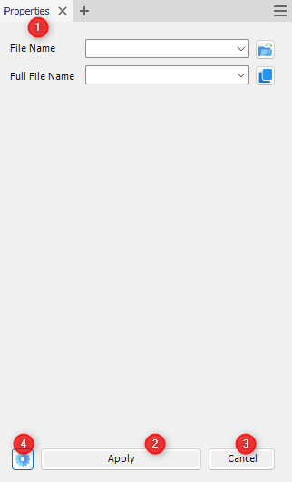
- File Information
- File Name (Default)
  - Dropdown or input to select a specific file name.
  - Open File Button: Opens a dialog to browse and select a file.
- Full File Name (Default)
  - Displays the complete path of the selected file.
  - Copy Path Button: Copies the full file path to your clipboard.

- Apply Button
- Click Apply to save any changes made to the file’s iProperties.

- Cancel Button
- Click Cancel to exit without saving any changes.

- Settings Button (⚙️)
- Opens the tool's settings window.
- Lets you configure property groups, presets, or load/save configuration files
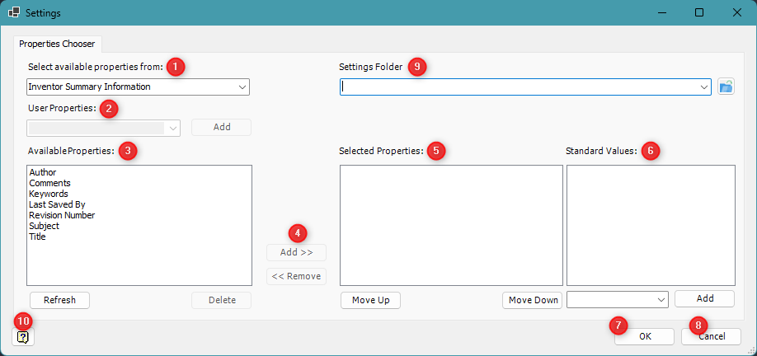
The Settings window allows you to configure which iProperties appear in the main tool, assign standard values, and manage settings storage.
- Select Available Properties From
- Drop down menu to choose the source group of iProperties:
  - Inventor Summary Information
  - Inventor Document Summary Information
  - Inventor Design Tracking Properties
  - Inventor Custom Properties
  - Physical Properties
- User Properties
- Enter the name of a custom iProperty.
- Press Add to include it in the list of available properties.
- Available Properties
- Shows all available properties from the selected source group.
- Use Refresh to reload the list.
- Use Delete to remove a selected custom property.
- Add/Remove Buttons
- Add >>: Move selected properties to the Selected Properties list.
- << Remove: Remove selected properties from the list of properties to be used in the main tool.
- Selected Properties
- Displays properties currently selected for display/edit in the main form.
- Use Move Up and Move Down to reorder them.
- Standard Values
- Define commonly used values for the currently selected property.
- Enter value in the box and click Add to include it as a suggestion in the dropdown.
- OK Button
- Save changes and close the Settings window.
- Cancel Button
- Close the window without saving changes.
- Settings Folder
- Specify or browse to a folder where configuration files (JSON) will be stored.
- This allows the reuse of settings across sessions or machines.
- Help / About Button
- Opens help or about documentation with more details about using the Settings window.
Usage Steps
- Click the Settings button to open the Settings dialog.
- Select Property’s Name in Available Properties to Selected Properties.
- Add standard value if needed (Optional).
- Click OK to apply your settings.

INSTALLATION
Overview
This guide walks you through installing the Di-Tools application (version 3.0) on a Windows system. Di-Tools is packaged as a standalone executable installer and typically takes less than a minute to complete installation.
Installation Steps
- Step 1: Locate the Installer
- Find the file named Di-Tools 3.0.exe on your computer. This is the setup file for the Di-Tools application.
- Step 2: Run the Installer
- Right-click the file and choose Run as administrator to ensure the installer has sufficient permissions.
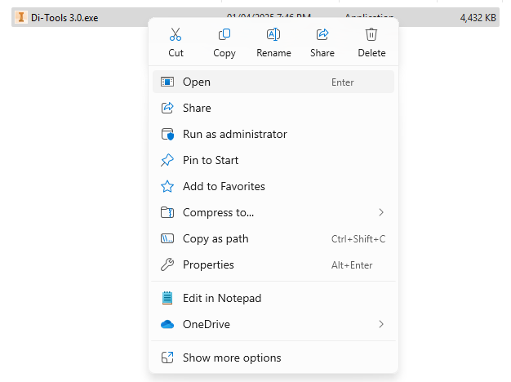
- Step 3: Begin Installation
- When the setup window appears, click Install to begin the installation process.
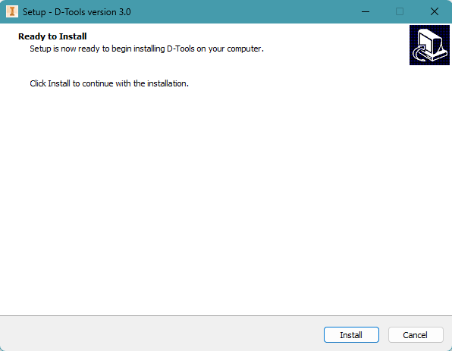💡
- You may be prompted by Windows Defender or UAC. If so, confirm that you trust the file and proceed.
- Step 4: Complete Installation
- After the installation finishes, you will see the Setup Complete screen. Click Finish to exit the installer.
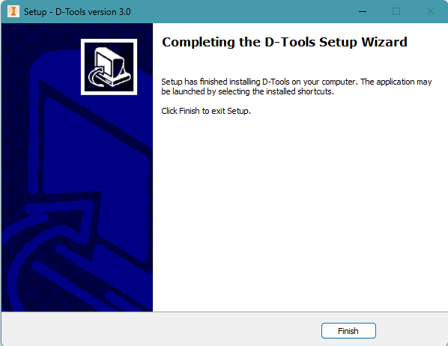
Activate Di-Tools in Autodesk Inventor
After installation, follow these steps to ensure Di-Tools is enabled inside Inventor.
Step 1: Open the Add-In Manager
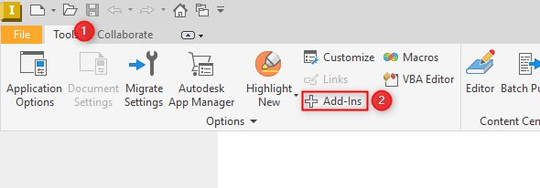
- Launch Autodesk Inventor.
- Go to the Tools tab (📌 1) on the ribbon.
- Click Add-Ins (📌 2).

Step 2: Enable Di-Tools Add-In
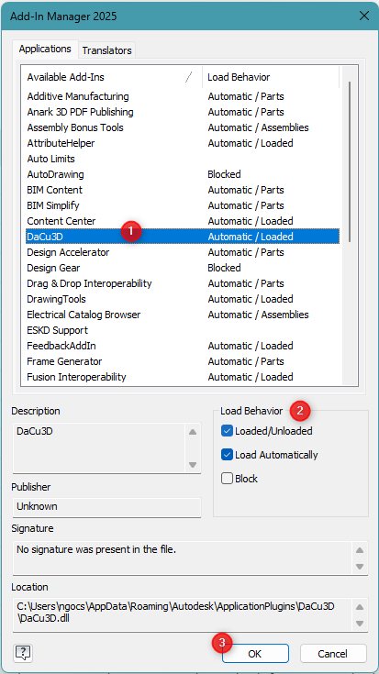
- In the Add-In Manager, scroll through the list and select DaCu3D (📌 1).
- On the right panel under Load Behavior (📌 2), check both:
  - ✅ Loaded/Unloaded
  - ✅ Load Automatically
- Click OK to save changes (📌 3).

Activate Your Di-Tools License
After installation and launching Inventor, you must activate your license to begin using Di-Tools.
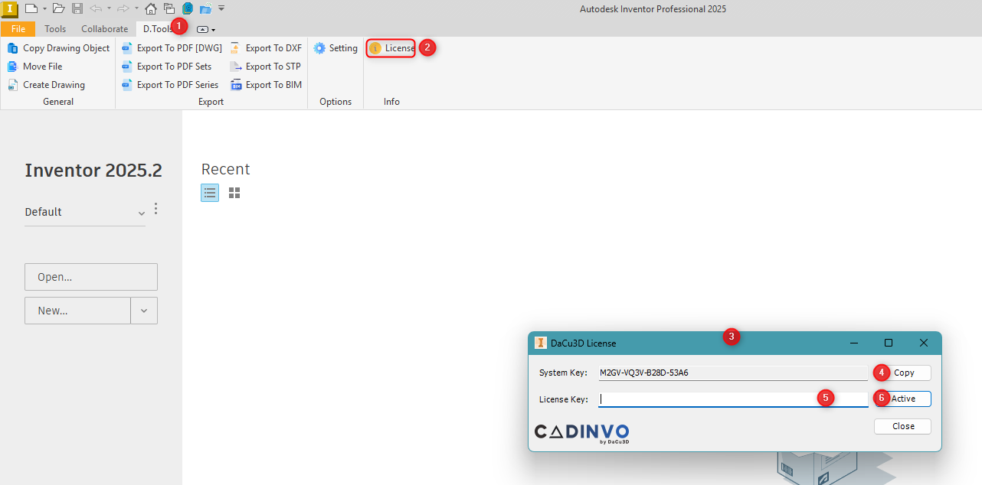
Step 1: Open the License Panel
- Go to the Di-Tools tab (📌 1) in Autodesk Inventor.
- Click the License button (📌 2) on the right.
Step 2: Copy the System Key
- In the DaCu3D License window (📌 3), your unique System Key is displayed.
- Click Copy (📌 4) to copy the key to your clipboard.

Step 3: Request a License Key
- Send the copied System Key to the CADINVO team by email orders@cadinvo.com
- You will receive a License Key in return.

Step 4: Activate
- Paste the License Key into the corresponding field (📌 5).
- Click Active (📌 6) to activate the software.
✅ If successful, the license window will close automatically and Di-Tools will be fully unlocked.
✅ You’re Done!
🎉 Special Thanks
Thank you for choosing Di-Tools by CADINVO.
We are incredibly grateful for your support and trust in our tools. Your feedback, suggestions, and continued use help us improve and build smarter, faster solutions for Inventor users like you.
If you encounter any issues or have ideas to enhance Di-Tools, don’t hesitate to reach out — we’re always here to help.
– The CADINVO Team
Innovating with you, for you.

